Source <https://www.rte.ie/news/upfront/2024/0212/1431886-two-experts-debate-the-dublin-airport-passenger-cap/> February 2024

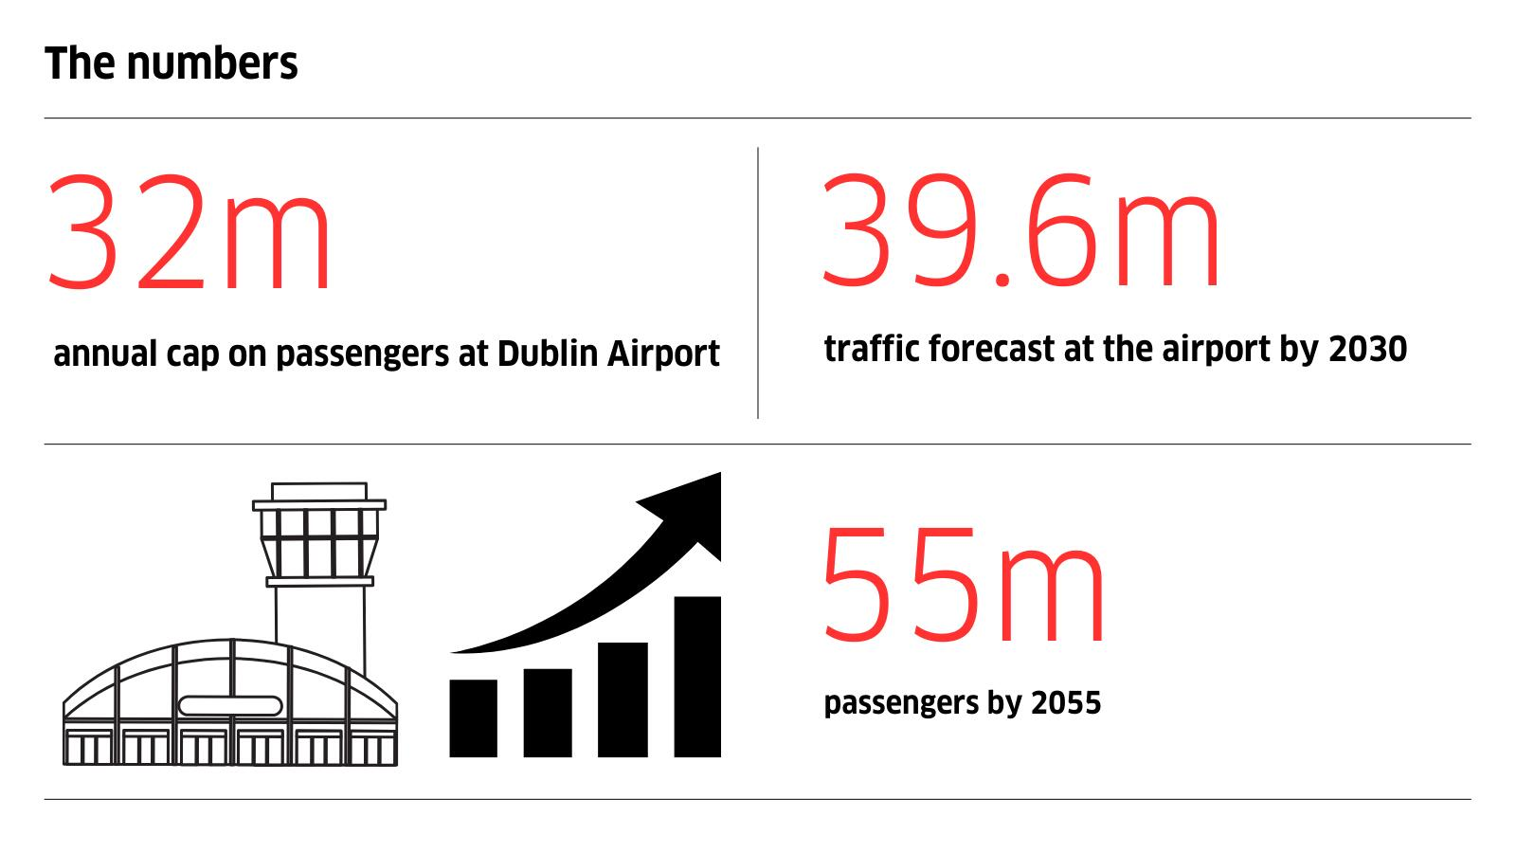

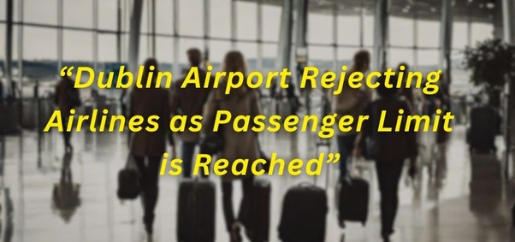

In a move that sparked major debate and divided government parties, the company responsible for the operation of Dublin Airport applied in December for planning permission to increase a cap on passenger numbers.

The application would see the cap on passenger numbers increased to 40m annually, from 32m.

The cap limits environmental emissions linked to the activity of the airport but those who want to see it increased argue the current cap constricts economic activity.

Taoiseach Leo Varadkar supports the application by the company which operates the airport, daa. However, local Green Party TD and Minister for State, Joe O'Brien, opposes it.

As part of The Conversation from RTÉ's Upfront with Katie Hannon, we asked two people to join our WhatsApp group to discuss the proposal.

Professor in Sustainable Energy at University College Cork, Hannah Daly, says increasing the cap will increase greenhouse gas emissions at a time when we've committed to cutting them.

Aidan Sweeney, Head of Enterprise and Regulatory Affairs at IBEC, believes the cap must be lifted due to our population growth and the need for international connectivity.